SECTION A: Multiple-choice questions (1 mark each)
Question 1

Answer: C

Explanation:
Plastic can be burnt to release thermal energy. This is an example of a linear economy that is polluting. Most plastic is made from crude oil and burning the plastic means it is not recycled in any way.
Fish and chip oil is made from plant oils rather than fossil fuels, so it is more renewable than plastic.

Question 2

Answer: B

Explanation:
Respiration of glucose releases 2803 kJ of energy and photosynthesis requires the same amount of energy. One is absorbing energy while the other process is releasing energy but the amount of energy is the same.

Question 3

Answer: A

Explanation:
Each of the 3 hydrocarbon chains in oil react with a methanol molecule to form a molecule of biodiesel. Only one molecule of glycerol is formed for each oil molecule.

Question 4

Answer: D

Explanation:
CH₄(g) + 2O₂(g) CO₂(g) + 2H₂O(l)

4 bonds in methane and 2 in oxygen break (total 6) forming 2 bonds in CO₂ and 2 bonds in each water molecule (total 6)

Question 5

Answer: C

Explanation:
90 g ethane = 90/30 = 3 mol
n(CO₂) = 2n(ethane) = 6 mol
mass = 6 x 44 = 264 g

Question 6

Answer: B

Explanation:
V= n x 24.8 (water is not a gas at SLC) = 6 x 24.8 = 149 L

Question 7

Answer: A

Explanation:
The equation has been reversed (-88 +88), then halved (88 44)

Question 8

Answer: B

Explanation:
5 mole of aluminium requires 5 x 3 = 15 mol of HCl. HCl is the limiting reagent.
Amount of energy released from 12 mol of HCl = 88x 6/3 = 176 kJ

Question 9

Answer: C

Explanation:
Mass of protein = 255/17 = 15 g
Bar weighs 50 g => mass oil = 50 – 15 = 35 g

Question 10

Answer: D

Explanation:
A: 1 mol H₂ = 286 kJ
B: 0.1 mol ethane = 136 kJ
C: 0.1 x 2803 = 280 kJ
D: 0.5 mol methane = 445 kJ

SECTION B: Short-answer questions

Question 1 (9 marks)
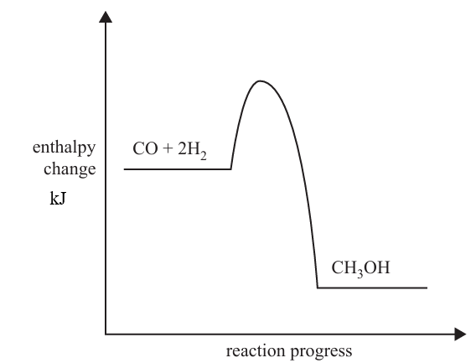
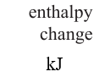
180
A

0
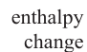

-320
B

a. i. CO(g) + 3H(g) CH₃OH(l) ΔH = -320 kJ 1 mark

ii. see above 2 marks

iii. 500 kJ 1 mark

b. i. C—O single bonds and H—H bonds 1 mark

ii. C—H C—O O—H 1 mark

iii. The above reaction is exothermic. Therefore the magnitude of the energy required to break the bonds is less than the energy produced when the bonds form? 1 mark

c. n(CO) = 50/28 = 1.79 mol
energy = 1.79 x 320 = 571 kJ 2 marks

Question 2 (16 marks)

a. i. 6CO₂(g) + 6H₂O(l) C₆H₁₂O₆(aq) + 6O₂(g) 1 mark

ii. C₆H₁₂O₆(aq) 2C₂H₆O(aq) + 2CO₂(g) 1 mark

iii. C₂H₆O(l) + 2O₂(g) 2CO(g) + 3H₂O(l) 1 mark

b. Fermentation is a reaction of glucose. Steps B and C convert the cellulose into glucose by grinding and pulping it and then breaking the glucose polymer down to glucose. 2 marks

c. The alcohol solution needs to be heated to at least 78⁰C for the ethanol to start boiling. The ethanol turns to a gas that rises out of the container. At a temperature under 78 ⁰C, no separation occurs. The temperature won’t rise above 78 ⁰C until the ethanol has boiled out. (In an industrial plant that runs continuously, the operation is often conducted at 85 ⁰C where the ethanol is a gas and the water a liquid) 2 marks

d. i. 1200 x 6500 (figure above) = 7.8 x 10⁶ L. 1 mark

ii. m = 7.8 x 10⁶ x 790 = 6.2 x 10⁹ g 1 mark

iii. energy =6.2 x 10⁹ x 29.7 = 1.8 x 10¹¹ kJ 2 marks

e. E10 fuel (solvent , camping stoves). 1 mark

f. The figures are not contradictory, they just have different units.
The 1367 is per mole => energy per gram = 1367/46 = 29.7 matching the second figure. 2 marks

g. Use of renewable feedstock is the obvious GCP to refer to as the crop can be regrown each year. 2 marks

Question 3 (11 marks)

a. i. KOH is used as a catalyst to break the three ester bonds in the triglyceride. The hydrocarbon chains each react with a methanol molecule to form a biodiesel molecule. One glycerol molecule is produced from each triglyceride molecule. 3 marks

ii. No – the 3 hydrocarbon chains on the triglyceride are of different lengths. They will form slightly different biodiesel molecules. 2 marks

iii. canola oil (waste fish and chip oil) 1 mark

b. i. The triglyceride 1 mark

ii. The triglyceride has a higher proportion of C-H bonds rather than C-O bonds. The energy of the C- H bonds must be higher. 2 marks

c. C₆H₁₂O₆(aq) + 6O₂(g) 6CO₂(g) + 6H₂O(l) 1 mark

d. 10 x 37 + 10 x 16 = 530 1 mark

Question 4 (4 marks)
a. 2C₂H₆(g) + 7O₂(g) 4CO₂(g) + 6H₂O(l) ΔH = 3120 kJ 1 mark
or half of all values above

b. i. 1560 kJ mol⁻¹ 1 mark

ii. -1560 kJ mol⁻¹ 1 mark

c. ΔH will be lower than 1560 kJ mol⁻¹ if the water remains as a gas. 1 mark

